Assignment – 1
Feedforward neural networks in Python using Keras and TensorFlow

Problem Statement:
The objective of this assignment is to implement a Feedforward Neural Network (FNN) using Keras and TensorFlow in Python. A feedforward neural network is a type of artificial neural network where connections between nodes do not form cycles, and the data flows in one direction—from input to output. The task is to build a simple FNN to solve a classification problem, such as recognizing handwritten digits using the MNIST dataset.

Software used:
- Python 3.x
- Google Colab

Libraries and packages used:
- TensorFlow/Keras: For building and training the neural network.
- Numpy: For numerical computations and array manipulations.
- Matplotlib: For visualizing data and performance metrics.
- Sklearn: For data preprocessing and performance evaluation.
- Keras: A high-level API for building neural networks, making it easy to prototype and implement.

Theory:
A Feedforward Neural Network (FNN) is the simplest form of neural network architecture. It consists of an input layer, hidden layers, and an output layer. The neurons in each layer are fully connected to the next layer without any backward loops.
Components of FNN:
- Input Layer: Accepts the features of the dataset.
- Hidden Layers: Non-linear layers that apply transformations to the input data to capture complex patterns.
- Output Layer: Produces the final predictions, typically using activation functions like softmax for classification problems.
The training of a feedforward neural network is done using backpropagation and gradient descent to minimize the loss function.

Methodology:
- Data Preparation: Load and preprocess the dataset (MNIST in this case).
- Define the Model: Create a sequential feedforward model using Keras.
- Compile the Model: Define the optimizer, loss function, and evaluation metrics.
- Train the Model: Use the training data to fit the model and adjust weights.
- Evaluate the Model: Test the model's performance on unseen data.
- Visualize Results: Plot the training accuracy and loss

Advantages:
- Simple to Implement: Feedforward networks are easy to construct and train.
- Effective for Simple Tasks: They work well for structured data and basic classification tasks.
- Easy to Scale: Can be expanded by adding more layers to improve accuracy.

Limitations:
- Limited Learning Capacity: Not suitable for complex tasks like image recognition without deep architecture.
- Prone to Overfitting: Especially if not regularized properly.
- Not Ideal for Sequential Data: Unlike recurrent neural networks, FNNs cannot handle temporal dependencies.

Applications with example:
- Image Classification: FNNs can be used to classify handwritten digits (e.g., MNIST dataset).
- Regression Tasks: They can predict continuous values (e.g., house prices).
Example: Classifying MNIST digits (0-9) using a feedforward neural network, which contains 60,000 training examples and 10,000 test examples.

Working / Algorithm:
- Load the dataset (e.g., MNIST).
- Preprocess data (normalize input and one-hot encode labels).
- Define the model architecture.
- Compile the model (specify optimizer, loss function, and metrics).
- Train the model with training data.
- Evaluate the model on test data.

Diagram:
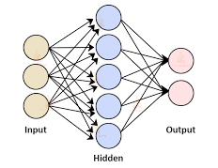

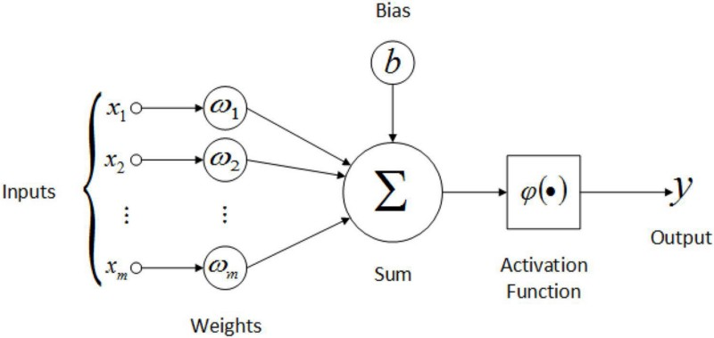

Conclusion:
The implementation of a Feedforward Neural Network using Keras and TensorFlow in Python demonstrates how simple neural networks can be applied to tasks such as image classification. By defining a model, compiling it with appropriate loss functions and optimizers, and training it on data like the MNIST dataset, FNNs can effectively solve many classification problems. Although basic feedforward networks are limited in their capacity to handle more complex tasks, they provide a solid foundation for understanding the principles of deep learning.

